BATCH NO. :B1-1M3E
SUBMITTED BY : JAYASHREE.R

SMART HOME AUTOMATION USING TINKERCAD
CIRCUIT DESIGN:

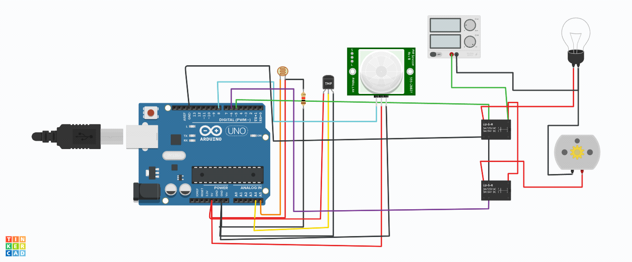
CIRCUIT CODE:

float x,y,z,temp;
void setup()
{
pinMode(8, INPUT);
pinMode(5, OUTPUT);
pinMode(6, OUTPUT);
pinMode(A5, INPUT);
pinMode(A4, INPUT);
Serial.begin(9600);
}
void loop()
{
x= digitalRead(8);
y= analogRead(A5);
z= analogRead(A4);
Serial.println(x);
Serial.println(y);
Serial.println(z);
temp = (double)z / 1024;
temp = temp * 5;
temp = temp - 0.5;
temp = temp * 100;
if ( (x>0) )
{
if ((y<550)&&(temp>30))
{
digitalWrite(5, HIGH);
digitalWrite(6, HIGH);
}
else if((y<550)&&(temp<30))
{
digitalWrite(5, HIGH);
digitalWrite(6, LOW);
}
else if((y>550)&&(temp>30))
{
digitalWrite(5, LOW);
digitalWrite(6, HIGH);
}
else if((y>550)&&(temp<30))
{
digitalWrite(5, LOW);
digitalWrite(6, LOW);
}
}
else
{
digitalWrite(5, LOW);
digitalWrite(6, LOW);
}
}

